**Streamlit ApplicationOverview:**

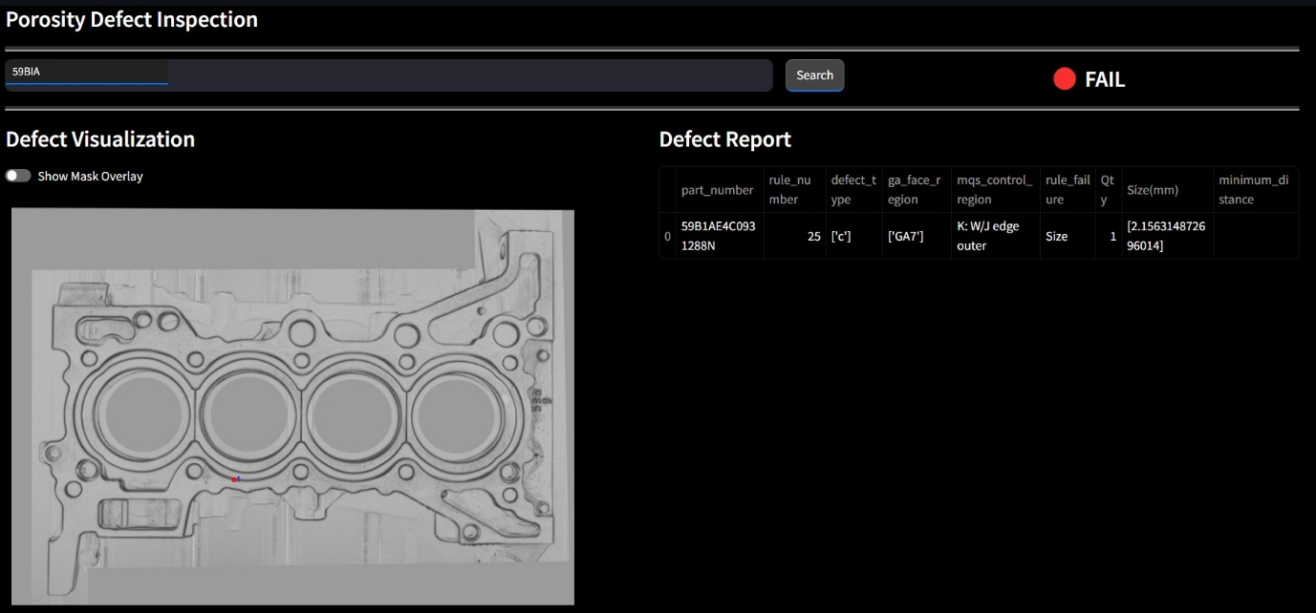

This application is a Streamlit-based web interface designed to facilitate the inspection of porosity defects by querying and visualizing defect-related data. The application interacts with AWS services including Amazon S3 and DynamoDB to retrieve and display images, defect masks, and reports.

**FeaturesSearch by Block Number:**

Input a block number to query the DynamoDB table and fetch relevant information.

Defect Visualization: Display localized defect images with an optional mask overlay.

Defect Report: View CSV-based defect reports if available.

Pass/Fail Status: Displays inspection status based on the presence of defect data.

**PrerequisitesEnsure you have the following before running the application:**

Python 3.8+

AWS credentials configured (with access to S3 and DynamoDB)

**Required Python packages:**

pip install streamlit pandas boto3 pillow streamlit-image-zoomAWS ConfigurationThe application uses the following AWS resources:

Amazon S3: Stores localized images, mask overlays, and defect reports in CSV format.

DynamoDB: Contains metadata and S3 file locations.

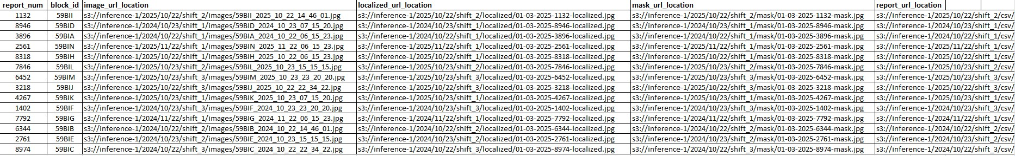

Environment VariablesEnsure your AWS credentials are properly configured through aws configure or environment variables.

Directory Structure.

├── app.py

└── README.mdDynamoDB Table SchemaThe application queries the DynamoDB table data_logs with the following key structure:

AttributeTypeDescriptionblock_idStringUnique identifier for blocksimage_url_locationStringS3 URL for localized imagemask_url_locationStringS3 URL for mask imagelocalized_url_locationStringS3 URL for localized imagereport_url_locationStringS3 URL for CSV reportUsageRun the Streamlit Application

streamlit run app.pySearch for a Block Number

Enter a block number in the search bar.

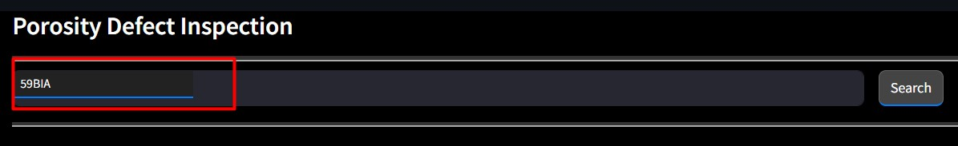

Click the "Search" button to fetch and display related data.

**Inspect Defects**

View the localized image of the defect.

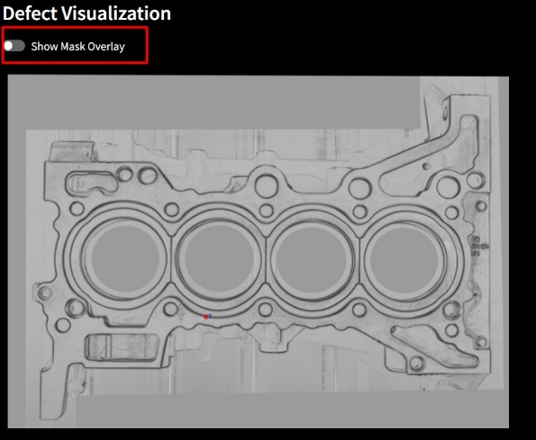

Toggle the "Show Mask Overlay" to visualize the defect mask.

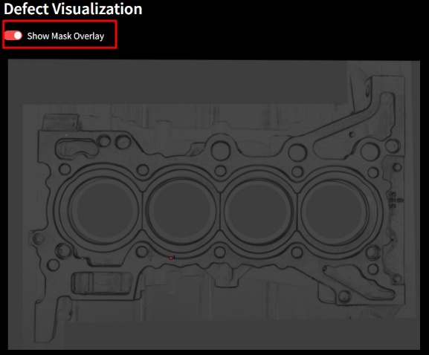

**Check Inspection Status**

"🔴 FAIL" is displayed if a defect report is found.

"🟢 PASS" if no defect report is available.

**View CSV Report**

Displays tabular data from the defect CSV if present.

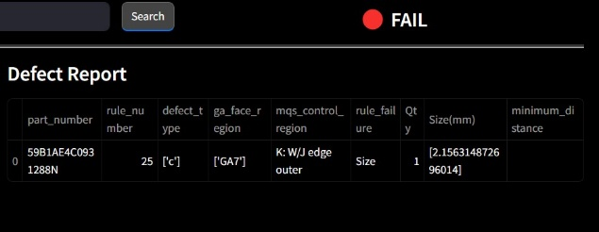

Code StructureAWS Clients Initializations3 = boto3.client("s3")

*dynamodb = boto3.resource("dynamodb")*

*table = dynamodb.Table(DYNAMODB_TABLE)Query DynamoDBdef query_dynamodb(block_id):*

*response = table.scan(FilterExpression=boto3.dynamodb.conditions.Attr('block_id').eq(block_id))*

*return response.get("Items", [])Fetch S3 Filesdef fetch_s3_file(s3_url):*

*bucket, key = s3_url.replace("s3://", "").split("/", 1)*

*response = s3.get_object(Bucket=bucket, Key=key)*

*return response['Body'].read()Image Visualizationimage_zoom(blended_image, mode="scroll", size=(700, 500), keep_aspect_ratio=True, zoom_factor=8.0, increment=0.8)*

Custom StylingThe application includes custom CSS for a dark theme and improved UI elements.

Error HandlingDisplays warnings if no data is found.

Error messages are shown for failed image loads.

CustomizationModify AWS resource names by changing BUCKET_NAME and DYNAMODB_TABLE

**Deploying an streamlit application on AWS EC2**

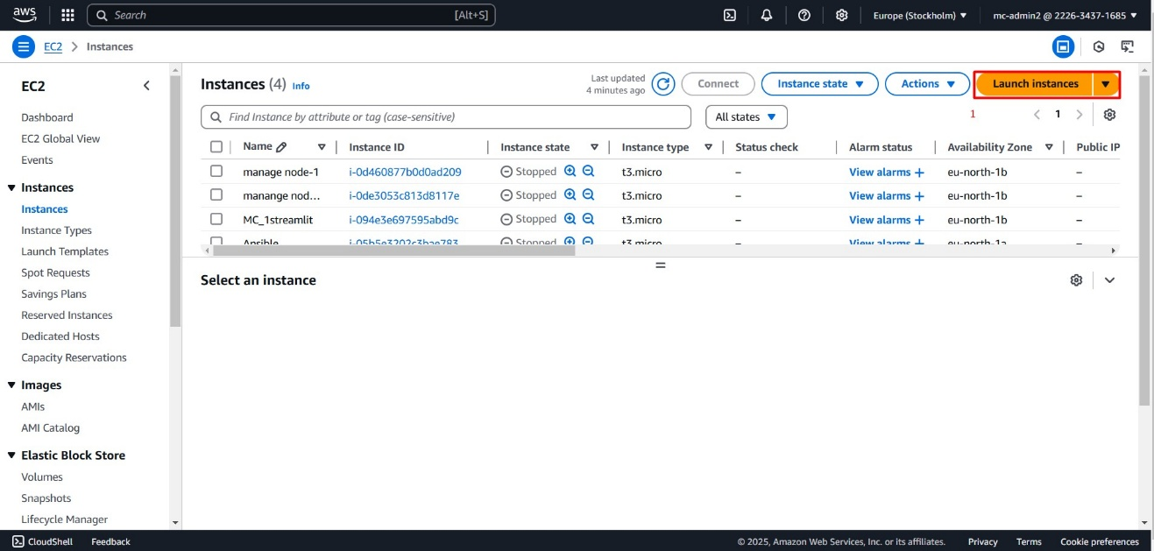launching an instances

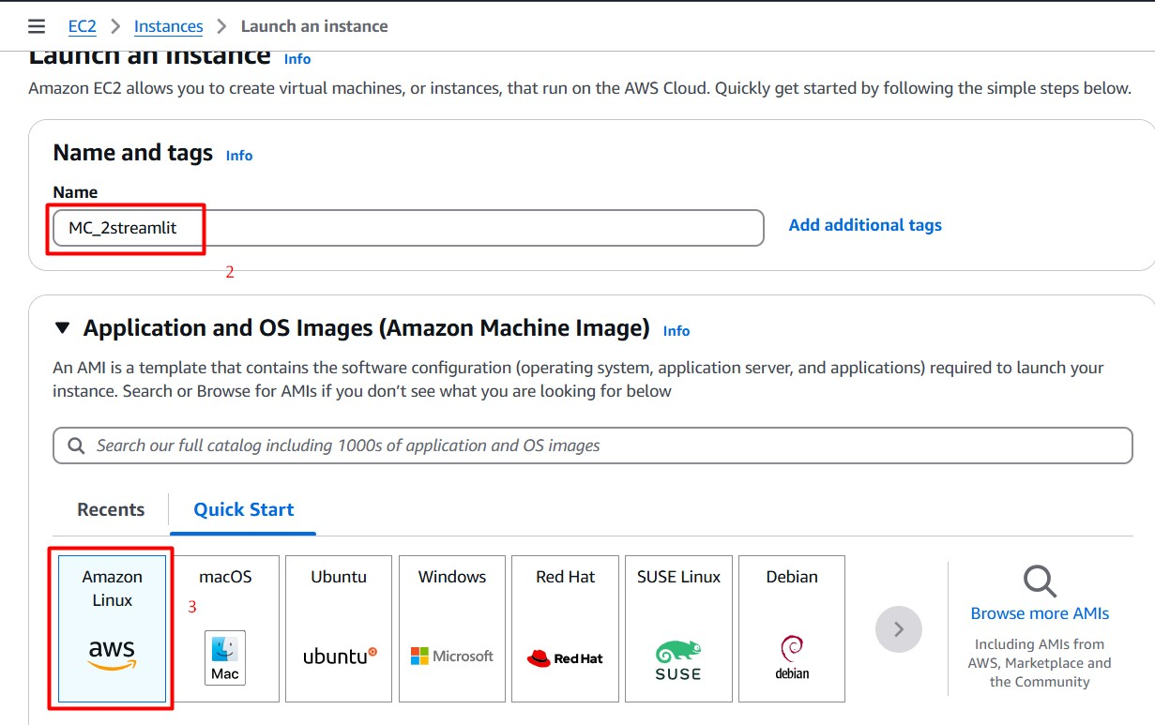

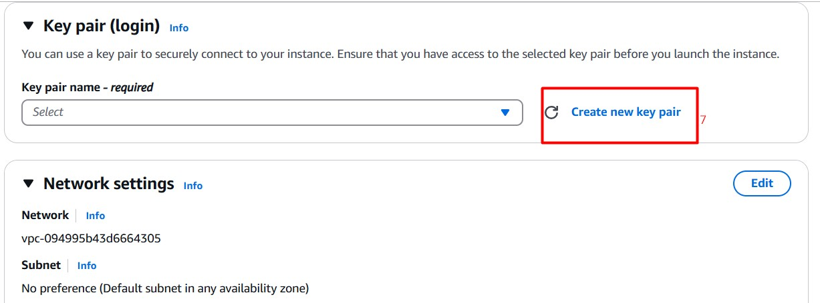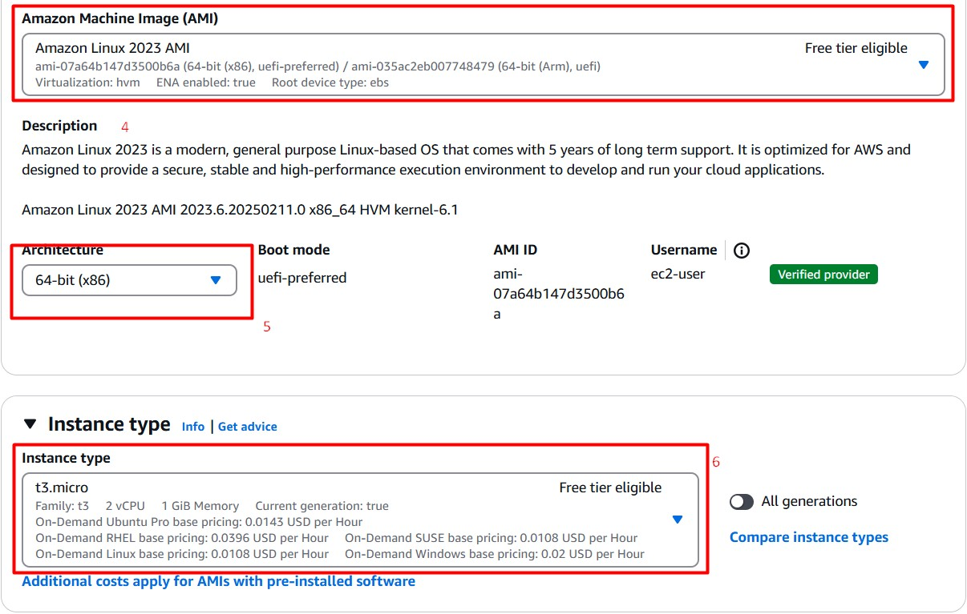

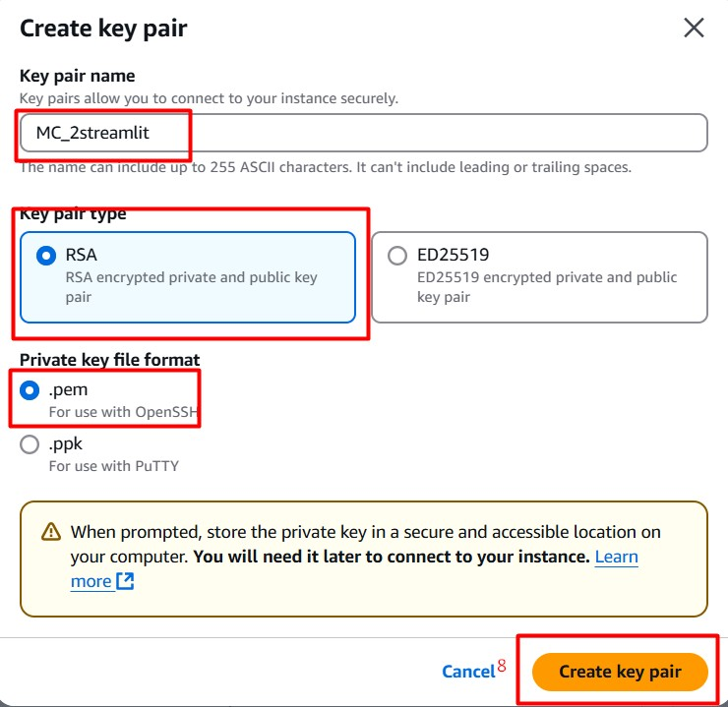

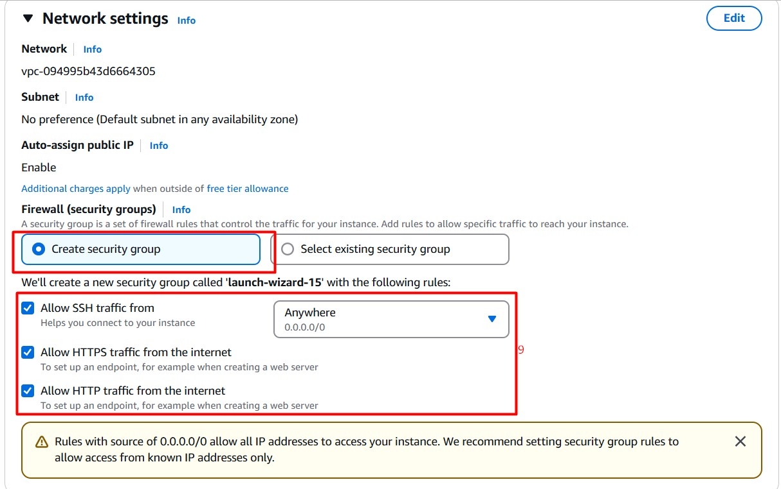

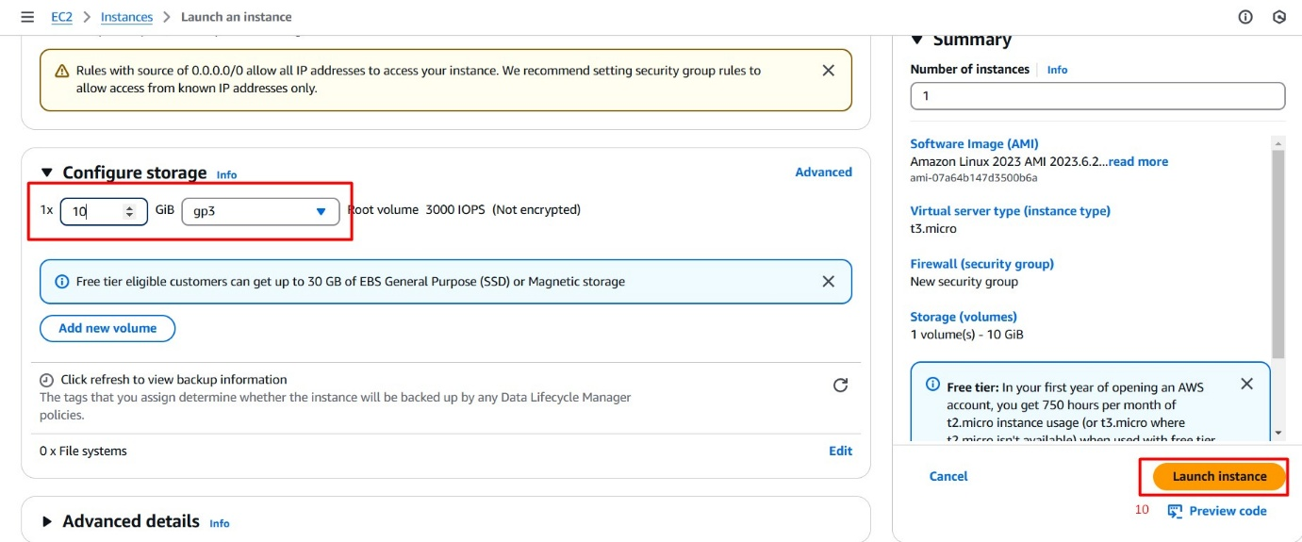

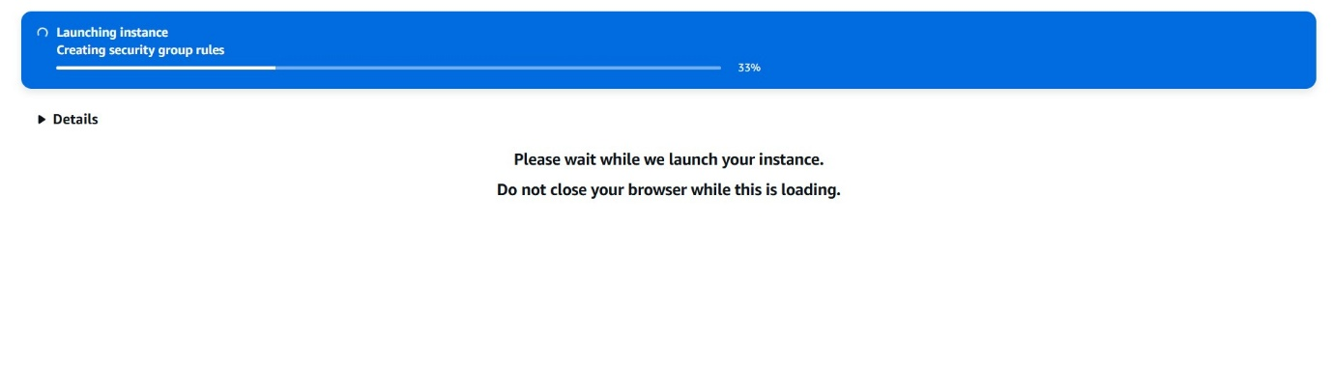

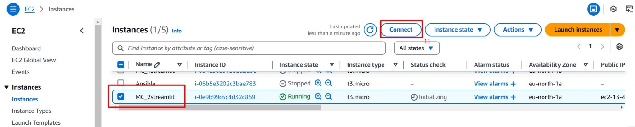

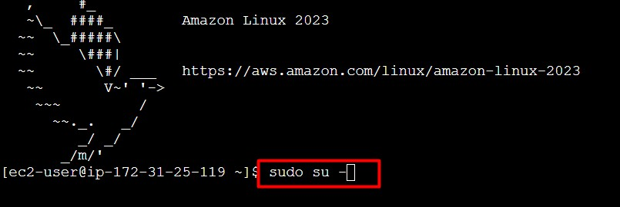

Installing git

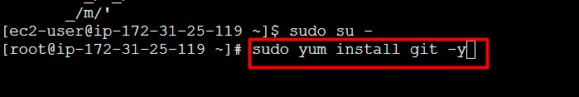

Installing httpd

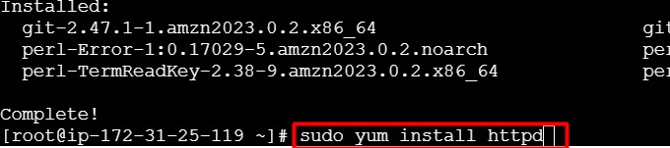

Clone the git repo where the application was

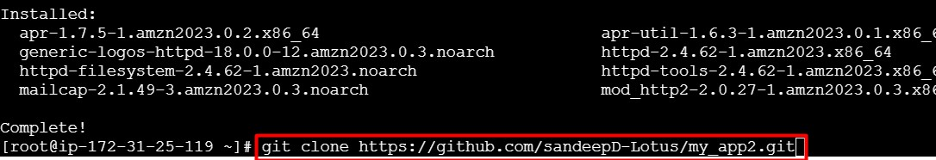

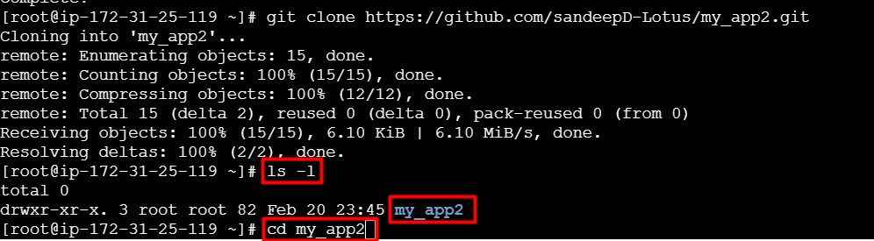

Installing the python3

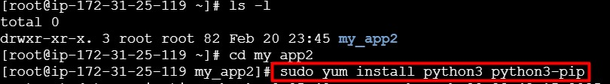

Creating the virtual environment

